Homework 1: The basics

(aka Putting the FUN in FUNdamentals of Web Servers)

In this course, we will be deploying a LAMP stack on the Raspberry Pi and creating and deploying a website on it. This homework activity aims to familiarize you with some of the fundamental concepts you will learn in the process.

# The LAMP stack

* 1. Briefly describe what is a LAMP stack and all the elements of a LAMP stack.
  2. Besides a Raspberry Pi, where can a LAMP stack be deployed?

It is very useful for large scale websites with a lot of traffic.

# IDE

Developing a website requires the appropriate development tools.

* 1. What is an [Integrated Development Environment](https://en.wikipedia.org/wiki/Integrated_development_environment) or IDE?

It’s the place where you can code and compile your code/project.

* 1. Briefly describe what [Visual Studio Code](https://code.visualstudio.com/) is/does. (Note that Visual Studio and Visual Studio Code are [distinct](https://stackoverflow.com/questions/30527522/what-are-the-differences-between-visual-studio-code-and-visual-studio) Microsoft products.)

Locate Visual Studio Code (*not* Visual Studio) on the lab computer and open it. Include a screenshot.

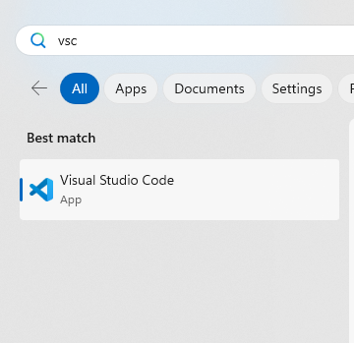

# GitHub

* 1. What is GitHub? Briefly explain how it is used for versioning and collaboration.

It is an online space where you can create a repository for your projects, collaborate with others, and it includes versioning.

* 1. Create a free [GitHub account](https://github.com/join) if you do not already have one.
  2. Create a new [GitHub repository](https://docs.github.com/en/get-started/quickstart/create-a-repo). Give it a friendly name (e.g. webserverfunds). Initialize your repository with a readme that contains a brief description of its purpose (e.g. “In fulfillment of the requirements of Dawson Electrotech Fundamentals of Web Servers”).
  3. Clone your repository to your local machine:
     1. Open GitHub desktop client.
     2. [Log in](https://docs.github.com/en/desktop/installing-and-configuring-github-desktop/overview/getting-started-with-github-desktop) to GitHub with the credentials you configured above.
     3. [Clone](https://docs.github.com/en/desktop/contributing-and-collaborating-using-github-desktop/adding-and-cloning-repositories/cloning-and-forking-repositories-from-github-desktop#cloning-a-repository) the repository to your local machine.
     4. Configure the local path (the folder on your local machine) that you want to clone to and make a note of it for the next step.

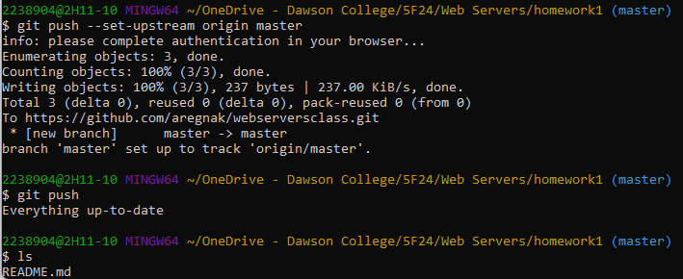

1. Make a local change and push it to your remote repository on GitHub:
   1. Open a text editor and create a file “helloworld.txt” with the text “Hello world!”. Save it to the directory where your local repository is stored.
   2. Navigate back to GitHub desktop. You should see your new file listed under [Changes](https://docs.github.com/en/desktop/contributing-and-collaborating-using-github-desktop/making-changes-in-a-branch/committing-and-reviewing-changes-to-your-project#selecting-changes-to-include-in-a-commit), with the option to add it to your local repository.
   3. [Commit](https://docs.github.com/en/desktop/contributing-and-collaborating-using-github-desktop/making-changes-in-a-branch/committing-and-reviewing-changes-to-your-project#write-a-commit-message-and-push-your-changes) your changes. Enter a summary of your changes and, optionally, description, and click “commit to main”. This saves the changes to your local repository and ensures that any further changes to your file will be tracked and versioned.
   4. Finally, push your changes to the remote repository by clicking “Push origin”. This synchronizes your changes and ensures that both your local and remote repositories reflect the same content.
   5. Navigate back to the GitHub website and verify that the *helloworld.txt* file has been correctly added. Include a screenshot.

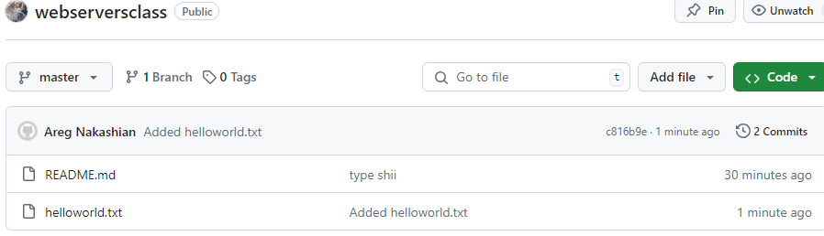

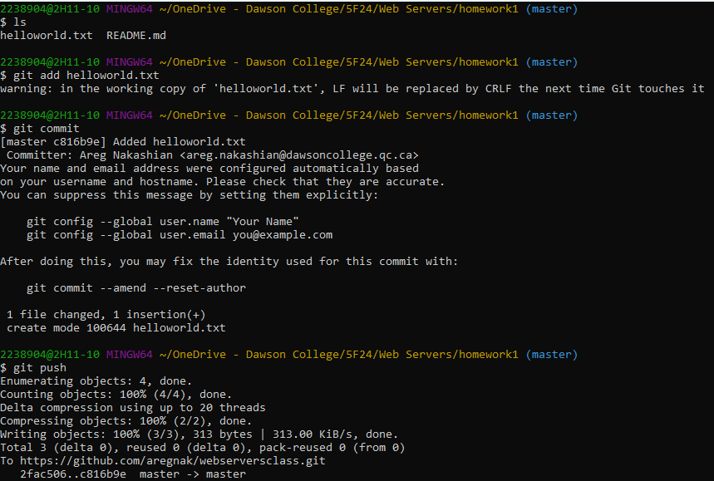

* 1. Copy and paste the link to your repository in your submission.
  2. Include the link to the specific commit where the file *helloworld.txt* was added:
     1. View the list of all commits:

* + 1. The hash corresponds to a specific commit. You can think of a hash as a unique code identifying the commit. If you click on the hash, you can view a detailed summary of all the changes you made:

* + 1. To view a snapshot of the repository at that specific moment in its history, click <>. The page that opens is the link you should submit with your lab. (Alternately, you can right-click and copy the link from the context menu.)

# The Raspberry Pi

For this course and others (e.g. Wireless LANs and your Projects course), you will need to purchase a Raspberry Pi.

* 1. What is a single board computer?
  2. Examine the [tech specs of the Raspberry Pi 5](https://www.raspberrypi.com/products/raspberry-pi-5/) and answer the following questions:
     1. What CPU architecture does it use? What speed does the processor run at?
     2. What are the available RAM options? Of these, which do you think is most compatible with the minimum requirements of your proposed project? For example, if you were planning a memory-intensive application like image processing, you would opt for more memory.
     3. How many GPIO pins does it expose?
     4. What operating system software is typically used on the Raspberry Pi?
  3. Visit the [Raspberry Pi foundation website](https://www.raspberrypi.org/blog/astro-pi-mission-space-lab-2022-23-results/) and list three applications of the Raspberry Pi aboard the International Space Station (created by children!).
  4. Conduct a web search for “raspberry pi projects” and/or browse the Raspberry Pi foundation [website](https://online.coolestprojects.org/events/cp-2024/gallery) and link to the project(s) you found the:
     1. coolest
     2. most useful (to you)
     3. most similar to what you envision for your Projects course
  5. Keeping in mind the minimum memory specifications for your Pi that you determined above, purchase your Raspberry Pi 5 (if you haven’t yet already):
     1. You can order a complete kit or purchase the following items individually:
* Raspberry Pi 5 Required
* 27W USB-C power supply Required
* 32 GB (or greater) micro-SD card and reader Required
* Raspberry Pi 40-pin breakout board Highly recommended
* Case and heat sinks Highly recommended
* Micro-HDMI cable, keyboard, mouse Optional
  + 1. You can purchase from the following retailers, depending on price and availability. You should aim to receive your kit within the next 2 – 3 weeks.
* [Abra](https://abra-electronics.com/?match=all&subcats=Y&pcode_from_q=Y&pshort=Y&pfull=Y&pname=Y&pkeywords=Y&search_performed=Y&q=raspberry+pi+5&dispatch=products.search&security_hash=15a217f51042e24924e0befe60902706)
* [Amazon](https://www.amazon.ca/s?k=raspberry+pi+5&crid=2GANX40RBHELN&sprefix=raspberry+pi+5%2Caps%2C113&ref=nb_sb_noss_1)
* [CanaKit](https://www.canakit.com/raspberry-pi-5)
* [PiShop](https://www.pishop.ca/product-category/raspberry-pi/raspberry-pi-5/)